EX1: Please open the archive laborator2.zip, and inside you will find the “deadlock” folder. Go into it and compile the file using the command:
gcc -o deadlock deadlock.c -lpthread
Run the program. Does it get stuck? Is it a perfect lock?

Does it get stuck? → Yes, it does
Is the deadlock perfect (meaning does it happen for sure all the time) → No, it is not. Because of the following line of code: pthread_mutex_lock(&mtx[1-*param]);
For thread1, this will block the mutex at the index 0 and 1.
For thread2, this will block the mutex and index 1 and 0
Theoretically, depending on the order by which the threads access the function and blocks the mutex, it is possible that the mutex will not always block: if a thread accesses the resources, it blocks them and it frees them, then the other thread comes and the action repeats.
Everything should work properly and the deadlock should not occur

PRACTICE1: Create a perfect deadlock by adding a barrier before acquiring the first resource. Hint: You can use a pthread_barrier_t structure, see this function:
https://man7.org/linux/man-pages/man3/pthread_barrier_wait.3p.html

Code:
#define _XOPEN_SOURCE 600

#include <stdio.h>
#include <pthread.h>
#include <unistd.h>

pthread_mutex_t mtx[2];
pthread_barrier_t barrier;

void *ThrFunc(void *p)
{
int *param = (int *)p;
pthread_mutex_lock(&mtx[*param]); // here the thread takes the first resource
printf("Thread %d before lock\n", *param);
pthread_barrier_wait(&barrier); // here the thread waits for the other thread to take the second resource
pthread_mutex_lock(&mtx[1 - *param]); // here the thread takes the second resource
return 0;
}

int main()
{
pthread_t thr1;
pthread_t thr2;
int i1 = 0, i2 = 1;
pthread_barrier_init(&barrier, NULL, 2);

pthread_mutex_init(&mtx[0], NULL);
pthread_mutex_init(&mtx[1], NULL);

pthread_create(&thr1, NULL, ThrFunc, &i1);
pthread_create(&thr2, NULL, ThrFunc, &i2);

pthread_join(thr1, NULL);
pthread_join(thr2, NULL);

pthread_mutex_destroy(&mtx[0]);
pthread_mutex_destroy(&mtx[1]);

pthread_barrier_destroy(&barrier);
return 0;
}
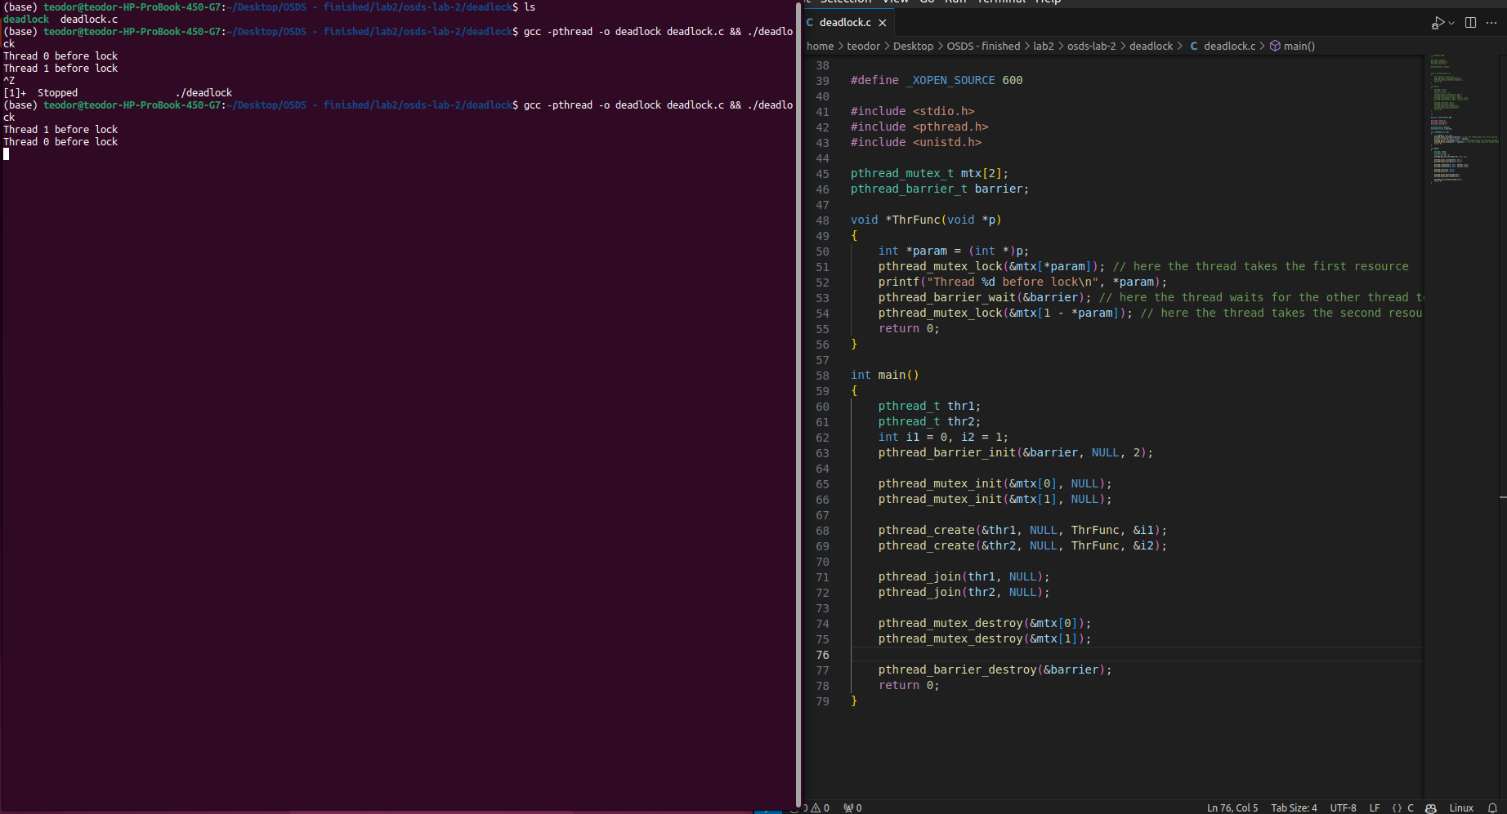

PRACTICE 2:
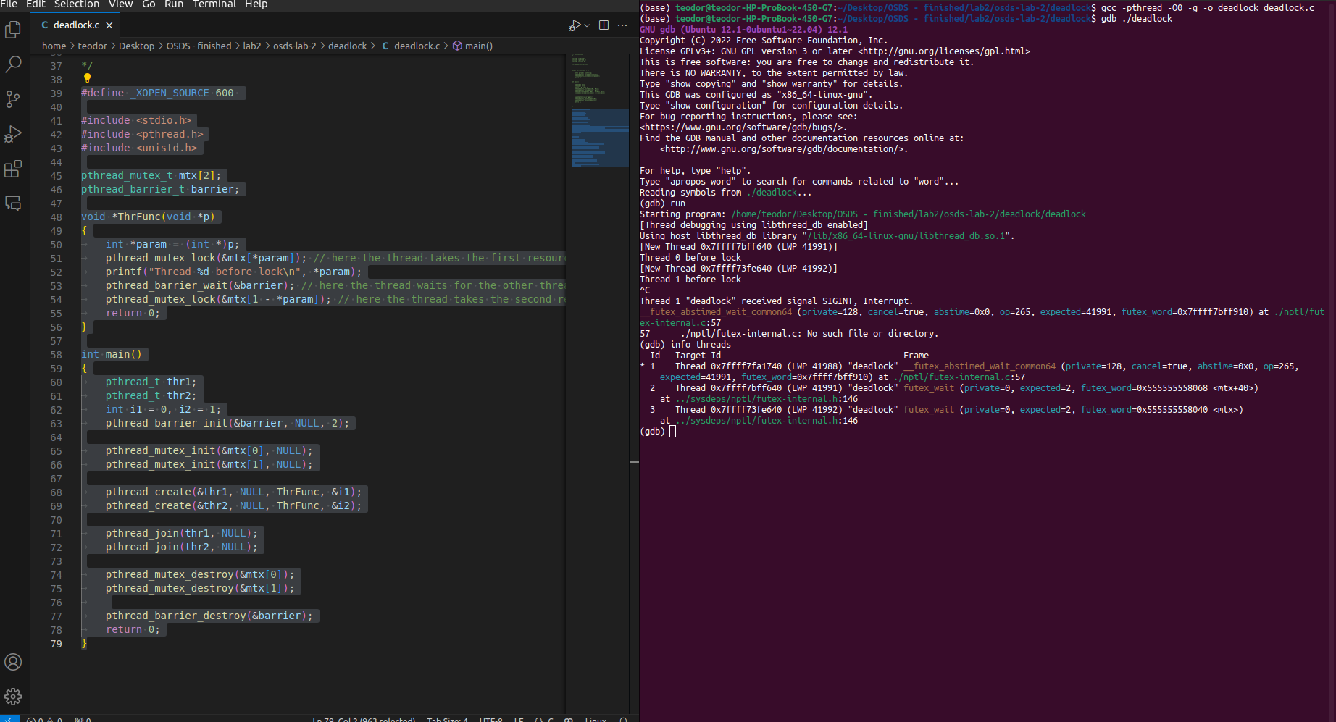
How many threads does it display? Why? → we only have 2 threads displayed. In the image we can see that one thread exited the execution, so we have only the main thread (which waits for the both threads to finish) and the others who waits for a source.

We repeat the steps:

Does info threads show you now 3 threads? Why? → Now, no thread exited execution. The main thread waits the other 2. Using barrier, we assure that each and every thread has a source before both can continue execution, moment when a perfect deadlock is created and the program blocks (no thread finished execution)

PRACTICE 3 : Read and implement the shared library (shlib.so) as described in the tutorial: https://sumit-ghosh.com/posts/hijacking-library-functions-code-injection-ld-preload/.
Exploit the “printf” function used in the main program to obtain shell access, similar to what’s done in the tutorial with the “__init_.s

